Title:

Online Booking System

Name: said wali

Reg #: fa22-bse-013

Submitted To: Sir Mukhtiyar Zamin

Date: 16/10/2024

Use Case Diagram:

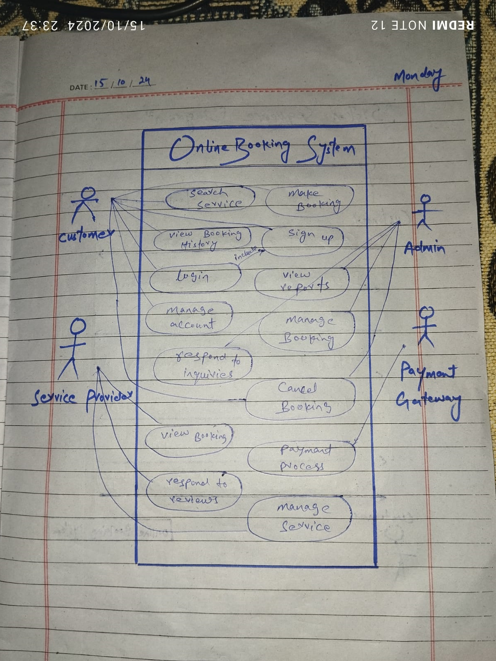

Fully dress

Use Case: Make Booking

1. Use Case Name: Make Booking

2. Actors:

* Customer: Initiates the booking process.
* Payment Gateway: Processes payment.
* Service Provider: Provides services (e.g., hotel, flight).

3. Goal: Allow a customer to search for available services and complete a booking with successful payment.

4. Preconditions:

* The customer must have an account and be logged in.
* Services (e.g., hotel rooms or flights) must be available.
* The payment gateway must be operational.

5. Postconditions:

* The booking is confirmed, and the customer receives a confirmation email.
* The service provider is notified of the booking.
* Payment is processed, and a receipt is generated.

6. Main Success Scenario (Basic Flow):

1. The customer logs into the system.
2. The customer searches for services (e.g., hotels, flights).
3. The system displays available options based on the customer’s search criteria.
4. The customer selects a service and proceeds to make a booking.
5. The system shows booking details (dates, service, price).
6. The customer confirms the booking and proceeds to the payment page.
7. The system includes the Process Payment use case to handle payment.
8. The payment gateway processes the payment successfully.
9. The system finalizes the booking and generates a confirmation.
10. The customer receives a booking confirmation email.

7. Alternative Flows:

* 7.1 Invalid Payment:
  + If payment fails, the system displays an error message and returns the customer to the payment page to retry.
* 7.2 Service Unavailable:
  + If the service selected becomes unavailable before the booking is finalized, the system notifies the customer and offers alternative options.

8. Exceptions:

* 8.1 Payment Gateway Unavailable:
  + If the payment gateway is down, the system prompts the customer to retry later and cancels the current booking attempt.

System Sequence Diagram:

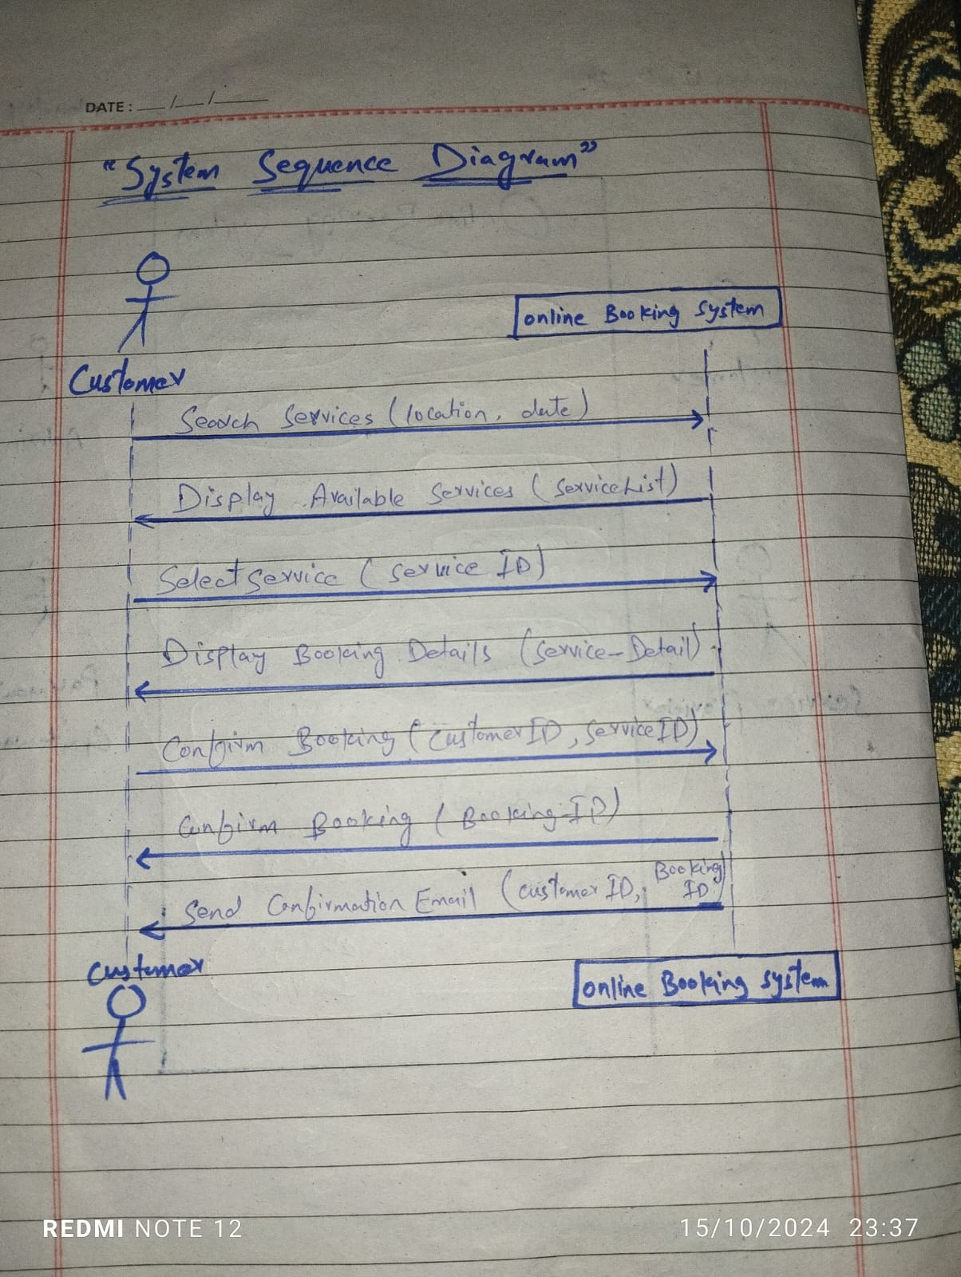

Communication Diagram:

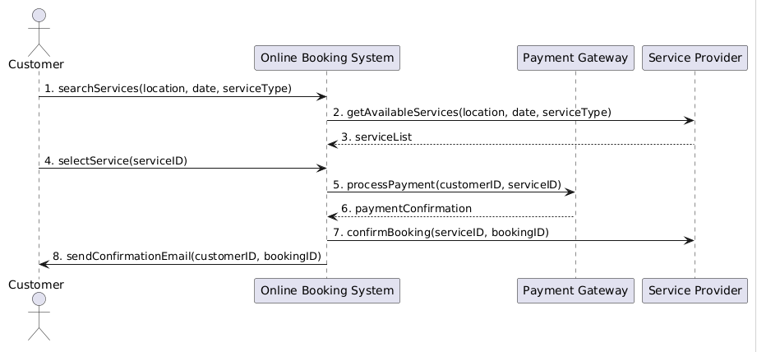

Class Diagram:

